**Mobile Application Development**

**Lab Assignment 12**

1. 1. Write program to get the following output with custom check box and custom checkbox and display the message with custom toast message.
2. Write program to get the following with default checkbox and radio button.
3. Write program to get the output given below.
4. Write a program to have app with takes your name ,usn and city. For city include autocomplete feature. Button should be included, on click of button display the details entered.

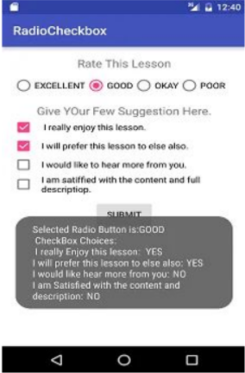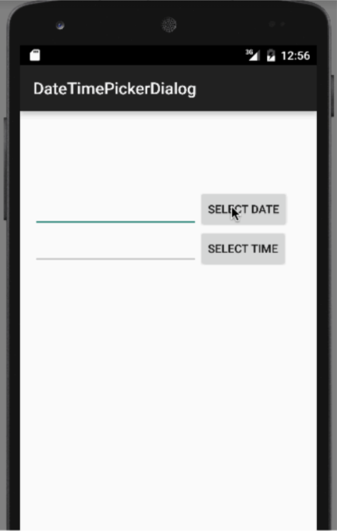

Normal checkbox and radio buttons:

activity_main.xml:

<?xml version="1.0" encoding="utf-8"?>

<androidx.constraintlayout.widget.ConstraintLayout xmlns:android="http://schemas.android.com/apk/res/android"

xmlns:app="http://schemas.android.com/apk/res-auto"

xmlns:tools="http://schemas.android.com/tools"

android:layout_width="match_parent"

android:layout_height="match_parent"

tools:context=".MainActivity">

<TextView

android:id="@+id/textView"

android:layout_width="wrap_content"

android:layout_height="wrap_content"

android:text="Rate This Lesson"

android:textSize="20dp"

app:layout_constraintBottom_toBottomOf="parent"

app:layout_constraintHorizontal_bias="0.498"

app:layout_constraintLeft_toLeftOf="parent"

app:layout_constraintRight_toRightOf="parent"

app:layout_constraintTop_toTopOf="parent"

app:layout_constraintVertical_bias="0.042" />

<RadioGroup

android:id="@+id/radioGroup"

android:layout_width="290dp"

android:layout_height="61dp"

android:orientation="horizontal"

app:layout_constraintBottom_toBottomOf="parent"

app:layout_constraintEnd_toEndOf="parent"

app:layout_constraintHorizontal_bias="0.495"

app:layout_constraintStart_toStartOf="parent"

app:layout_constraintTop_toTopOf="parent"

app:layout_constraintVertical_bias="0.117">

<RadioButton

android:id="@+id/radioButton2"

android:layout_width="wrap_content"

android:layout_height="wrap_content"

android:text="Excellent"

app:layout_constraintBottom_toBottomOf="parent"

app:layout_constraintEnd_toEndOf="parent"

app:layout_constraintHorizontal_bias="0.077"

app:layout_constraintStart_toStartOf="parent"

app:layout_constraintTop_toTopOf="parent"

app:layout_constraintVertical_bias="0.134" />

<RadioButton

android:id="@+id/radioButton3"

android:layout_width="wrap_content"

android:layout_height="wrap_content"

android:text="Good"

app:layout_constraintBottom_toBottomOf="parent"

app:layout_constraintEnd_toEndOf="parent"

app:layout_constraintHorizontal_bias="0.408"

app:layout_constraintStart_toStartOf="parent"

app:layout_constraintTop_toTopOf="parent"

app:layout_constraintVertical_bias="0.133" />

<RadioButton

android:id="@+id/radioButton4"

android:layout_width="wrap_content"

android:layout_height="wrap_content"

android:text="Ok"

app:layout_constraintBottom_toBottomOf="parent"

app:layout_constraintEnd_toEndOf="parent"

app:layout_constraintHorizontal_bias="0.657"

app:layout_constraintStart_toStartOf="parent"

app:layout_constraintTop_toTopOf="parent"

app:layout_constraintVertical_bias="0.133" />

<RadioButton

android:id="@+id/radioButton5"

android:layout_width="wrap_content"

android:layout_height="wrap_content"

android:text="Poor"

app:layout_constraintBottom_toBottomOf="parent"

app:layout_constraintEnd_toEndOf="parent"

app:layout_constraintHorizontal_bias="0.908"

app:layout_constraintStart_toStartOf="parent"

app:layout_constraintTop_toTopOf="parent"

app:layout_constraintVertical_bias="0.133" />

</RadioGroup>

<TextView

android:id="@+id/textView2"

android:layout_width="wrap_content"

android:layout_height="wrap_content"

android:text="Give your few suggestions here"

android:textSize="20dp"

app:layout_constraintBottom_toBottomOf="parent"

app:layout_constraintEnd_toEndOf="parent"

app:layout_constraintHorizontal_bias="0.454"

app:layout_constraintStart_toStartOf="parent"

app:layout_constraintTop_toTopOf="parent"

app:layout_constraintVertical_bias="0.254" />

<CheckBox

android:id="@+id/checkBox"

android:layout_width="wrap_content"

android:layout_height="wrap_content"

android:text="I really enjoyed this lesson"

app:layout_constraintBottom_toBottomOf="parent"

app:layout_constraintEnd_toEndOf="parent"

app:layout_constraintHorizontal_bias="0.28"

app:layout_constraintStart_toStartOf="parent"

app:layout_constraintTop_toTopOf="parent"

app:layout_constraintVertical_bias="0.348" />

<CheckBox

android:id="@+id/checkBox4"

android:layout_width="wrap_content"

android:layout_height="wrap_content"

android:text="I am satisfied with the content"

app:layout_constraintBottom_toBottomOf="parent"

app:layout_constraintEnd_toEndOf="parent"

app:layout_constraintHorizontal_bias="0.324"

app:layout_constraintStart_toStartOf="parent"

app:layout_constraintTop_toTopOf="parent"

app:layout_constraintVertical_bias="0.559" />

<CheckBox

android:id="@+id/checkBox3"

android:layout_width="wrap_content"

android:layout_height="wrap_content"

android:text="I would like to hear more from you"

app:layout_constraintBottom_toBottomOf="parent"

app:layout_constraintEnd_toEndOf="parent"

app:layout_constraintHorizontal_bias="0.361"

app:layout_constraintStart_toStartOf="parent"

app:layout_constraintTop_toTopOf="parent"

app:layout_constraintVertical_bias="0.489" />

<CheckBox

android:id="@+id/checkBox2"

android:layout_width="wrap_content"

android:layout_height="wrap_content"

android:text="I will recommend this lesson to others"

app:layout_constraintBottom_toBottomOf="parent"

app:layout_constraintEnd_toEndOf="parent"

app:layout_constraintHorizontal_bias="0.422"

app:layout_constraintStart_toStartOf="parent"

app:layout_constraintTop_toTopOf="parent"

app:layout_constraintVertical_bias="0.418" />

<Button

android:id="@+id/button"

android:layout_width="wrap_content"

android:layout_height="wrap_content"

android:text="Submit"

android:onClick="onclickbuttonMethod"

app:layout_constraintBottom_toBottomOf="parent"

app:layout_constraintEnd_toEndOf="parent"

app:layout_constraintHorizontal_bias="0.498"

app:layout_constraintStart_toStartOf="parent"

app:layout_constraintTop_toTopOf="parent"

app:layout_constraintVertical_bias="0.663" />

</androidx.constraintlayout.widget.ConstraintLayout>

MainActivity.java:

package com.example.customcheckbox;

import androidx.appcompat.app.AppCompatActivity;

import android.os.Bundle;

import android.view.View;

import android.widget.Button;

import android.widget.CheckBox;

import android.widget.RadioButton;

import android.widget.RadioGroup;

import android.widget.Toast;

public class MainActivity extends AppCompatActivity {

Button button;

RadioButton ratedradioButton;

RadioGroup radioGroup;

CheckBox box1, box2, box3, box4;

@Override

protected void onCreate(Bundle savedInstanceState) {

super.onCreate(savedInstanceState);

setContentView(R.layout.*activity_main*);

radioGroup=(RadioGroup)findViewById(R.id.*radioGroup*);

}

public void onclickbuttonMethod(View v){

int selectedId = radioGroup.getCheckedRadioButtonId();

ratedradioButton = (RadioButton) findViewById(selectedId);

box1=(CheckBox)findViewById(R.id.*checkBox*);

box2=(CheckBox)findViewById(R.id.*checkBox2*);

box3=(CheckBox)findViewById(R.id.*checkBox3*);

box4=(CheckBox)findViewById(R.id.*checkBox4*);

StringBuilder result = new StringBuilder();

result.append("Selected radio button: ");

if(selectedId==-1){

result.append("None");

}

else{

result.append(ratedradioButton.getText());

}

result.append("\nCheckbox choices: ");

if(box1.isChecked()){

result.append("\n").append(box1.getText()).append(": YES");

}

else{

result.append("\n").append(box1.getText()).append(": NO");

}

if(box2.isChecked()){

result.append("\n").append(box2.getText()).append(": YES");

}

else{

result.append("\n"+box2.getText()+": NO");

}

if(box3.isChecked()){

result.append("\n"+box3.getText()+": YES");

}

else{

result.append("\n"+box3.getText()+": NO");

}

if(box4.isChecked()){

result.append("\n"+box4.getText()+": YES");

}

else{

result.append("\n"+box4.getText()+": NO");

}

Toast.*makeText*(getApplicationContext(), result.toString(), Toast.*LENGTH_LONG*).show();

}

}

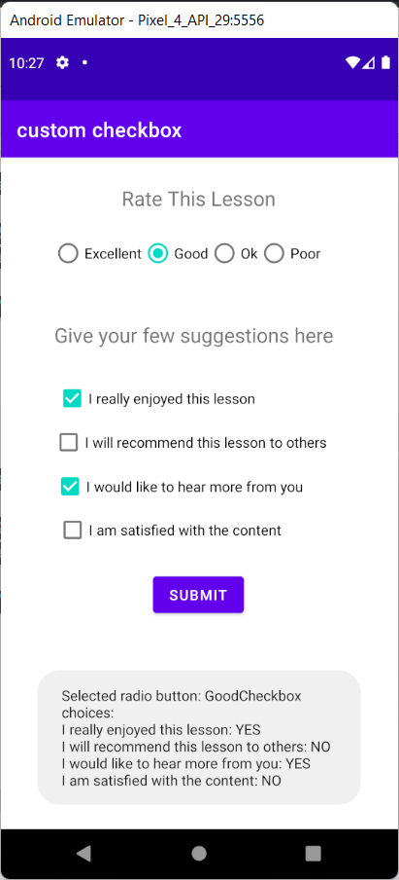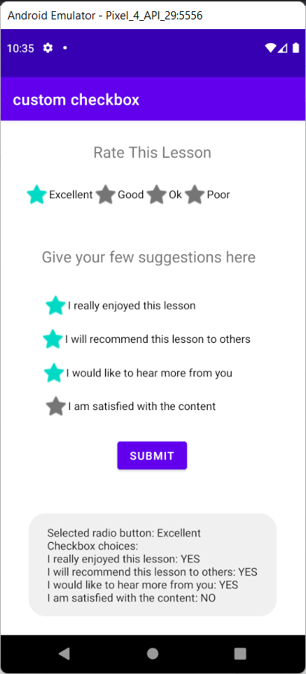

Custom checkbox and radio buttons:

activity_main.xml:

<?xml version="1.0" encoding="utf-8"?>

<androidx.constraintlayout.widget.ConstraintLayout xmlns:android="http://schemas.android.com/apk/res/android"

xmlns:app="http://schemas.android.com/apk/res-auto"

xmlns:tools="http://schemas.android.com/tools"

android:layout_width="match_parent"

android:layout_height="match_parent"

tools:context=".MainActivity">

<TextView

android:id="@+id/textView"

android:layout_width="wrap_content"

android:layout_height="wrap_content"

android:text="Rate This Lesson"

android:textSize="20dp"

app:layout_constraintBottom_toBottomOf="parent"

app:layout_constraintHorizontal_bias="0.498"

app:layout_constraintLeft_toLeftOf="parent"

app:layout_constraintRight_toRightOf="parent"

app:layout_constraintTop_toTopOf="parent"

app:layout_constraintVertical_bias="0.042" />

<RadioGroup

android:id="@+id/radioGroup"

android:layout_width="331dp"

android:layout_height="58dp"

android:orientation="horizontal"

app:layout_constraintBottom_toBottomOf="parent"

app:layout_constraintEnd_toEndOf="parent"

app:layout_constraintHorizontal_bias="0.495"

app:layout_constraintStart_toStartOf="parent"

app:layout_constraintTop_toTopOf="parent"

app:layout_constraintVertical_bias="0.117">

<RadioButton

android:id="@+id/radioButton2"

android:layout_width="wrap_content"

android:layout_height="wrap_content"

android:button="@android:drawable/btn_star"

android:text="Excellent"

app:layout_constraintBottom_toBottomOf="parent"

app:layout_constraintEnd_toEndOf="parent"

app:layout_constraintHorizontal_bias="0.077"

app:layout_constraintStart_toStartOf="parent"

app:layout_constraintTop_toTopOf="parent"

app:layout_constraintVertical_bias="0.134" />

<RadioButton

android:id="@+id/radioButton3"

android:layout_width="wrap_content"

android:layout_height="wrap_content"

android:button="@android:drawable/btn_star"

android:text="Good"

app:layout_constraintBottom_toBottomOf="parent"

app:layout_constraintEnd_toEndOf="parent"

app:layout_constraintHorizontal_bias="0.408"

app:layout_constraintStart_toStartOf="parent"

app:layout_constraintTop_toTopOf="parent"

app:layout_constraintVertical_bias="0.133" />

<RadioButton

android:id="@+id/radioButton4"

android:layout_width="wrap_content"

android:layout_height="wrap_content"

android:button="@android:drawable/btn_star"

android:text="Ok"

app:layout_constraintBottom_toBottomOf="parent"

app:layout_constraintEnd_toEndOf="parent"

app:layout_constraintHorizontal_bias="0.657"

app:layout_constraintStart_toStartOf="parent"

app:layout_constraintTop_toTopOf="parent"

app:layout_constraintVertical_bias="0.133" />

<RadioButton

android:id="@+id/radioButton5"

android:layout_width="wrap_content"

android:layout_height="wrap_content"

android:button="@android:drawable/btn_star"

android:text="Poor"

app:layout_constraintBottom_toBottomOf="parent"

app:layout_constraintEnd_toEndOf="parent"

app:layout_constraintHorizontal_bias="0.908"

app:layout_constraintStart_toStartOf="parent"

app:layout_constraintTop_toTopOf="parent"

app:layout_constraintVertical_bias="0.133" />

</RadioGroup>

<TextView

android:id="@+id/textView2"

android:layout_width="wrap_content"

android:layout_height="wrap_content"

android:text="Give your few suggestions here"

android:textSize="20dp"

app:layout_constraintBottom_toBottomOf="parent"

app:layout_constraintEnd_toEndOf="parent"

app:layout_constraintHorizontal_bias="0.454"

app:layout_constraintStart_toStartOf="parent"

app:layout_constraintTop_toTopOf="parent"

app:layout_constraintVertical_bias="0.254" />

<CheckBox

android:id="@+id/checkBox"

android:layout_width="wrap_content"

android:layout_height="wrap_content"

android:text="I really enjoyed this lesson"

android:button="@android:drawable/btn_star"

app:layout_constraintBottom_toBottomOf="parent"

app:layout_constraintEnd_toEndOf="parent"

app:layout_constraintHorizontal_bias="0.28"

app:layout_constraintStart_toStartOf="parent"

app:layout_constraintTop_toTopOf="parent"

app:layout_constraintVertical_bias="0.348" />

<CheckBox

android:id="@+id/checkBox4"

android:layout_width="wrap_content"

android:layout_height="wrap_content"

android:text="I am satisfied with the content"

android:button="@android:drawable/btn_star"

app:layout_constraintBottom_toBottomOf="parent"

app:layout_constraintEnd_toEndOf="parent"

app:layout_constraintHorizontal_bias="0.324"

app:layout_constraintStart_toStartOf="parent"

app:layout_constraintTop_toTopOf="parent"

app:layout_constraintVertical_bias="0.559" />

<CheckBox

android:id="@+id/checkBox3"

android:layout_width="wrap_content"

android:layout_height="wrap_content"

android:text="I would like to hear more from you"

android:button="@android:drawable/btn_star"

app:layout_constraintBottom_toBottomOf="parent"

app:layout_constraintEnd_toEndOf="parent"

app:layout_constraintHorizontal_bias="0.361"

app:layout_constraintStart_toStartOf="parent"

app:layout_constraintTop_toTopOf="parent"

app:layout_constraintVertical_bias="0.489" />

<CheckBox

android:id="@+id/checkBox2"

android:layout_width="wrap_content"

android:layout_height="wrap_content"

android:text="I will recommend this lesson to others"

android:button="@android:drawable/btn_star"

app:layout_constraintBottom_toBottomOf="parent"

app:layout_constraintEnd_toEndOf="parent"

app:layout_constraintHorizontal_bias="0.422"

app:layout_constraintStart_toStartOf="parent"

app:layout_constraintTop_toTopOf="parent"

app:layout_constraintVertical_bias="0.418" />

<Button

android:id="@+id/button"

android:layout_width="wrap_content"

android:layout_height="wrap_content"

android:text="Submit"

android:onClick="onclickbuttonMethod"

app:layout_constraintBottom_toBottomOf="parent"

app:layout_constraintEnd_toEndOf="parent"

app:layout_constraintHorizontal_bias="0.498"

app:layout_constraintStart_toStartOf="parent"

app:layout_constraintTop_toTopOf="parent"

app:layout_constraintVertical_bias="0.663" />

</androidx.constraintlayout.widget.ConstraintLayout>

MainActivity.java:

package com.example.customcheckbox;

import androidx.appcompat.app.AppCompatActivity;

import android.os.Bundle;

import android.view.View;

import android.widget.Button;

import android.widget.CheckBox;

import android.widget.RadioButton;

import android.widget.RadioGroup;

import android.widget.Toast;

public class MainActivity extends AppCompatActivity {

Button button;

RadioButton ratedradioButton;

RadioGroup radioGroup;

CheckBox box1, box2, box3, box4;

@Override

protected void onCreate(Bundle savedInstanceState) {

super.onCreate(savedInstanceState);

setContentView(R.layout.*activity_main*);

radioGroup=(RadioGroup)findViewById(R.id.*radioGroup*);

}

public void onclickbuttonMethod(View v){

int selectedId = radioGroup.getCheckedRadioButtonId();

ratedradioButton = (RadioButton) findViewById(selectedId);

box1=(CheckBox)findViewById(R.id.*checkBox*);

box2=(CheckBox)findViewById(R.id.*checkBox2*);

box3=(CheckBox)findViewById(R.id.*checkBox3*);

box4=(CheckBox)findViewById(R.id.*checkBox4*);

StringBuilder result = new StringBuilder();

result.append("Selected radio button: ");

if(selectedId==-1){

result.append("None");

}

else{

result.append(ratedradioButton.getText());

}

result.append("\nCheckbox choices: ");

if(box1.isChecked()){

result.append("\n").append(box1.getText()).append(": YES");

}

else{

result.append("\n").append(box1.getText()).append(": NO");

}

if(box2.isChecked()){

result.append("\n").append(box2.getText()).append(": YES");

}

else{

result.append("\n"+box2.getText()+": NO");

}

if(box3.isChecked()){

result.append("\n"+box3.getText()+": YES");

}

else{

result.append("\n"+box3.getText()+": NO");

}

if(box4.isChecked()){

result.append("\n"+box4.getText()+": YES");

}

else{

result.append("\n"+box4.getText()+": NO");

}

Toast.*makeText*(getApplicationContext(), result.toString(), Toast.*LENGTH_LONG*).show();

}

}

3. Date and time picker

Xml:

<?xml version="1.0" encoding="utf-8"?>

<androidx.constraintlayout.widget.ConstraintLayout xmlns:android="http://schemas.android.com/apk/res/android"

xmlns:app="http://schemas.android.com/apk/res-auto"

xmlns:tools="http://schemas.android.com/tools"

android:layout_width="match_parent"

android:layout_height="match_parent"

tools:context=".MainActivity">

<TextView

android:id="@+id/textView"

android:layout_width="wrap_content"

android:layout_height="wrap_content"

android:gravity="center"

android:text="Date and Time Picker"

android:textSize="25dp"

app:layout_constraintBottom_toBottomOf="parent"

app:layout_constraintHorizontal_bias="0.497"

app:layout_constraintLeft_toLeftOf="parent"

app:layout_constraintRight_toRightOf="parent"

app:layout_constraintTop_toTopOf="parent"

app:layout_constraintVertical_bias="0.045" />

<TextView

android:id="@+id/date"

android:layout_width="wrap_content"

android:layout_height="wrap_content"

android:text="Date"

android:textSize="25dp"

app:layout_constraintBottom_toBottomOf="parent"

app:layout_constraintEnd_toEndOf="parent"

app:layout_constraintHorizontal_bias="0.278"

app:layout_constraintStart_toStartOf="parent"

app:layout_constraintTop_toTopOf="parent"

app:layout_constraintVertical_bias="0.21" />

<Button

android:id="@+id/select_Date"

android:layout_width="wrap_content"

android:layout_height="wrap_content"

android:text="Date"

app:layout_constraintBottom_toBottomOf="parent"

app:layout_constraintEnd_toEndOf="parent"

app:layout_constraintHorizontal_bias="0.791"

app:layout_constraintStart_toStartOf="parent"

app:layout_constraintTop_toTopOf="parent"

app:layout_constraintVertical_bias="0.215" />

<TextView

android:id="@+id/time"

android:layout_width="wrap_content"

android:layout_height="wrap_content"

android:text="Time"

android:textSize="25dp"

app:layout_constraintBottom_toBottomOf="parent"

app:layout_constraintEnd_toEndOf="parent"

app:layout_constraintHorizontal_bias="0.278"

app:layout_constraintStart_toStartOf="parent"

app:layout_constraintTop_toTopOf="parent"

app:layout_constraintVertical_bias="0.334" />

<Button

android:id="@+id/select_Time"

android:layout_width="wrap_content"

android:layout_height="wrap_content"

android:text="Time"

app:layout_constraintBottom_toBottomOf="parent"

app:layout_constraintEnd_toEndOf="parent"

app:layout_constraintHorizontal_bias="0.792"

app:layout_constraintStart_toStartOf="parent"

app:layout_constraintTop_toTopOf="parent"

app:layout_constraintVertical_bias="0.341" />

</androidx.constraintlayout.widget.ConstraintLayout>

Java:

package com.example.datetimepicker;

import androidx.appcompat.app.AppCompatActivity;

import android.app.TimePickerDialog;

import android.os.Bundle;

import android.app.DatePickerDialog;

import android.view.View;

import android.widget.Button;

import android.widget.DatePicker;

import android.widget.TextView;

import android.widget.TimePicker;

import java.util.Calendar;

public class MainActivity extends AppCompatActivity implements DatePickerDialog.*OnDateSetListener* {

TextView date, time;

Button select_Date, select_Time;

Calendar calendar;

int year,month,dayOfMonth;

DatePickerDialog datePickerDialog;

TimePickerDialog picker;

@Override

protected void onCreate (Bundle savedInstanceState) {

super.onCreate(savedInstanceState);

setContentView(R.layout.*activity_main*);

date = (TextView) findViewById(R.id.*date*);

time = (TextView) findViewById(R.id.*time*);

select_Date = (Button) findViewById(R.id.*select_Date*);

select_Time = (Button) findViewById(R.id.*select_Time*);

calendar = Calendar.*getInstance*();

int hour = calendar.get(Calendar.*HOUR_OF_DAY*);

int minutes = calendar.get(Calendar.*MINUTE*);

select_Date.setOnClickListener(new View.OnClickListener() {

@Override

public void onClick(View v) {

datePicker();

}

});

select_Time.setOnClickListener(new View.OnClickListener() {

@Override

public void onClick(View v) {

timePicker();

}

});

}

public void datePicker() {

year=calendar.get(Calendar.*YEAR*);

month=calendar.get(Calendar.*MONTH*);

dayOfMonth=calendar.get(Calendar.*DAY_OF_MONTH*);

datePickerDialog = new DatePickerDialog(this, this, year, month, dayOfMonth);

datePickerDialog.show();

}

@Override

public void onDateSet(DatePicker view, int year, int month, int dayOfMonth) {

date.setText((month+1) + "-" + dayOfMonth + "-" + year);

}

public void timePicker() {

int hour = calendar.get(Calendar.*HOUR_OF_DAY*);

int minutes = calendar.get(Calendar.*MINUTE*);

picker = new TimePickerDialog(MainActivity.this, new TimePickerDialog.OnTimeSetListener() {

@Override

public void onTimeSet(TimePicker tp, int sHour, int sMinute) {

time.setText(sHour + ":" + sMinute);

}

}, hour, minutes, true);

picker.show();

}

}

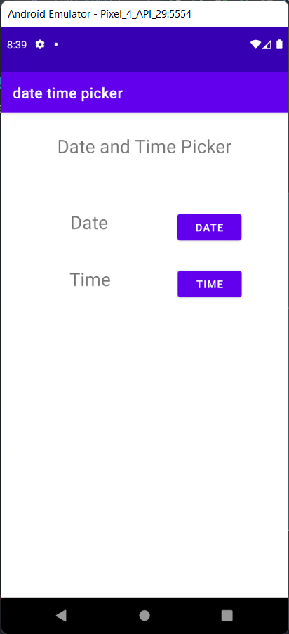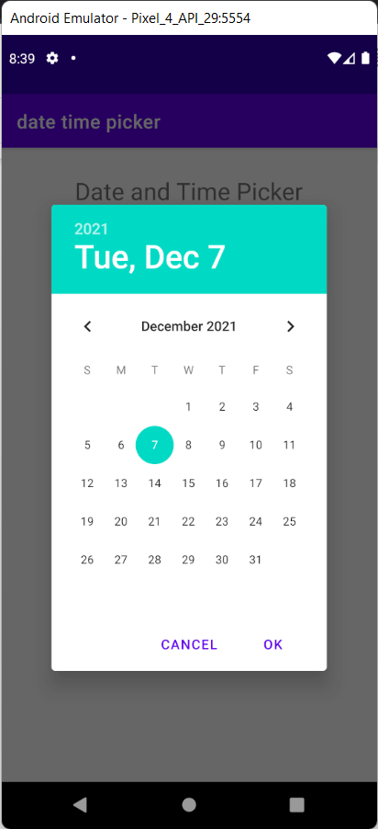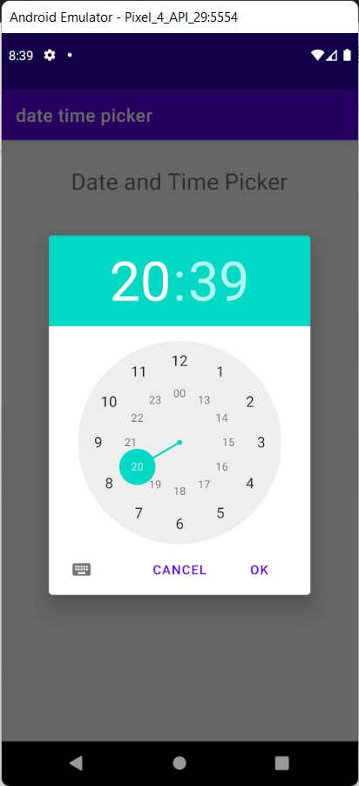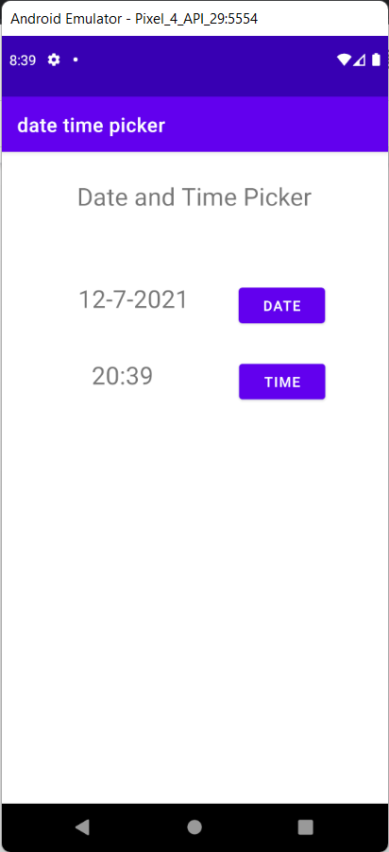

4. Autofill Program

Xml:

<?xml version="1.0" encoding="utf-8"?>

<androidx.constraintlayout.widget.ConstraintLayout xmlns:android="http://schemas.android.com/apk/res/android"

xmlns:app="http://schemas.android.com/apk/res-auto"

xmlns:tools="http://schemas.android.com/tools"

android:layout_width="match_parent"

android:layout_height="match_parent"

tools:context=".MainActivity">

<TextView

android:id="@+id/textView2"

android:layout_width="203dp"

android:layout_height="48dp"

android:text="Details"

android:gravity="center"

android:textSize="25dp"

app:layout_constraintBottom_toBottomOf="parent"

app:layout_constraintLeft_toLeftOf="parent"

app:layout_constraintRight_toRightOf="parent"

app:layout_constraintTop_toTopOf="parent"

app:layout_constraintVertical_bias="0.103" />

<TextView

android:id="@+id/textView"

android:layout_width="125dp"

android:layout_height="33dp"

android:gravity="left|center"

android:text="Name :"

app:layout_constraintBottom_toBottomOf="parent"

app:layout_constraintEnd_toEndOf="parent"

app:layout_constraintHorizontal_bias="0.213"

app:layout_constraintStart_toStartOf="parent"

app:layout_constraintTop_toTopOf="parent"

app:layout_constraintVertical_bias="0.227" />

<TextView

android:id="@+id/textView3"

android:layout_width="120dp"

android:layout_height="30dp"

android:gravity="left|center"

android:text="USN :"

app:layout_constraintBottom_toBottomOf="parent"

app:layout_constraintEnd_toEndOf="parent"

app:layout_constraintHorizontal_bias="0.209"

app:layout_constraintStart_toStartOf="parent"

app:layout_constraintTop_toTopOf="parent"

app:layout_constraintVertical_bias="0.319" />

<TextView

android:id="@+id/textView4"

android:layout_width="108dp"

android:layout_height="34dp"

android:gravity="left|center"

android:text="City :"

app:layout_constraintBottom_toBottomOf="parent"

app:layout_constraintEnd_toEndOf="parent"

app:layout_constraintHorizontal_bias="0.201"

app:layout_constraintStart_toStartOf="parent"

app:layout_constraintTop_toTopOf="parent"

app:layout_constraintVertical_bias="0.397" />

<Button

android:id="@+id/button"

android:layout_width="wrap_content"

android:layout_height="wrap_content"

android:text="Submit"

app:layout_constraintBottom_toBottomOf="parent"

app:layout_constraintEnd_toEndOf="parent"

app:layout_constraintHorizontal_bias="0.498"

app:layout_constraintStart_toStartOf="parent"

app:layout_constraintTop_toTopOf="parent"

app:layout_constraintVertical_bias="0.499" />

<EditText

android:id="@+id/editTextTextPersonName"

android:layout_width="168dp"

android:layout_height="51dp"

android:ems="10"

android:inputType="textPersonName"

android:text="Name"

app:layout_constraintBottom_toBottomOf="parent"

app:layout_constraintEnd_toEndOf="parent"

app:layout_constraintHorizontal_bias="0.843"

app:layout_constraintStart_toStartOf="parent"

app:layout_constraintTop_toTopOf="parent"

app:layout_constraintVertical_bias="0.219" />

<EditText

android:id="@+id/editTextTextPersonusn"

android:layout_width="168dp"

android:layout_height="52dp"

android:ems="10"

android:inputType="textPersonName"

android:text="Name"

app:layout_constraintBottom_toBottomOf="parent"

app:layout_constraintEnd_toEndOf="parent"

app:layout_constraintHorizontal_bias="0.843"

app:layout_constraintStart_toStartOf="parent"

app:layout_constraintTop_toTopOf="parent"

app:layout_constraintVertical_bias="0.315" />

<AutoCompleteTextView

android:id="@+id/editTextTextPersoncity"

android:layout_width="168dp"

android:layout_height="47dp"

android:ems="10"

android:inputType="textPersonName"

android:text="Name"

app:layout_constraintBottom_toBottomOf="parent"

app:layout_constraintEnd_toEndOf="parent"

app:layout_constraintHorizontal_bias="0.843"

app:layout_constraintStart_toStartOf="parent"

app:layout_constraintTop_toTopOf="parent"

app:layout_constraintVertical_bias="0.404" />

</androidx.constraintlayout.widget.ConstraintLayout>

Java:

package com.example.autofillprog;

import androidx.appcompat.app.AppCompatActivity;

import android.os.Bundle;

import android.graphics.Color;

import android.os.Bundle;

import android.widget.ArrayAdapter;

import android.widget.AutoCompleteTextView;

import android.graphics.Color;

import android.os.Bundle;

import android.widget.ArrayAdapter;

import android.widget.AutoCompleteTextView;

public class MainActivity extends AppCompatActivity {

String[] cities

={"Bangalore","Mumbai","Hyderabad","Chennai","Delhi","Lucknow","Kolkata","Agra"

};

@Override

protected void onCreate(Bundle savedInstanceState) {

super.onCreate(savedInstanceState);

setContentView(R.layout.activity_main);

ArrayAdapter<String> a= new ArrayAdapter<String>(this,

android.R.layout.select_dialog_item,cities);

AutoCompleteTextView a1

=(AutoCompleteTextView)findViewById(R.id.editTextTextPersoncity);a1.setThreshold(1);

a1.setAdapter(a);

a1.setTextColor(Color.RED);

}

}

